**ASSIGNMENT 2**

|  |  |  |  |
| --- | --- | --- | --- |
| **Qualification** | BTEC HND Diploma in Computing and Systems Development | | |
| **Unit number and title** | **Unit 6: Managing a Successful Computing Projects** | | |
| **Submission date** |  | **Assignment submitted (1st)** |  |
| **Re-Submission date** |  | **Assignment submitted (2nd)** |  |
| **Student name** | Phan Minh Tri | **Student ID** | GCC18015 |
| **Class** | GCC0701 | **Assessor name** | Truong Minh Thai |

|  |  |  |  |
| --- | --- | --- | --- |
| **Learner declaration:**  I certify that the work submitted for this assignment is my own and research sources are fully acknowledged. | | | |
| **Learner signature** |  | **Date** |  |

**Grading grid**

|  |  |  |  |  |  |
| --- | --- | --- | --- | --- | --- |
| P5 | P6 | P7 | M3 | M4 | D2 |
|  |  |  |  |  |  |

|  |  |
| --- | --- |
| **Assignment title** | **Assignment 2:** Project communication and recommendations |
| In this assignment, you will have opportunities to provide evidence against the following criteria.  Indicate the page numbers where the evidence can be found. | |

|  |  |  |  |
| --- | --- | --- | --- |
| **Assessment criteria** | **Expected evidence** | **Task no.** | **Assessor’s Feedback** |
| **LO3** Present the project and communicate appropriate recommendations based on meaningful conclusions drawn from the evidence findings and/or analysis**.** | | | |
| **P5** Analyze research and data using appropriate tools and techniques | Conduct research to generate knowledge which will form the basis for analysis of the scenario posed in the brief. Using analytical techniques for data and information analysis. Use of graphs, bar charts, pie charts etc. for presenting data. | 1 |  |
| **P6** Communicate appropriate recommendations as a result of research and data analysis to draw valid and meaningful conclusions | Analyze your findings and draw conclusions to form the basis for recommendations | 2 |  |
| **LO4** Reflect on the value gained from conducting the project and its usefulness to support sustainable organizational performance. | | | |
| **P7** Reflect on the value of undertaking the research to meet stated objectives and own learning and performance | Reflect on the success of your project and your own performance in a **personal performance review** at the end of the project. This is a written reflection of around 500 words. | 3 |  |

|  |  |  |
| --- | --- | --- |
| **Assessment criteria** | **Expected Evidence** | **Feedback**  **(note on Merit/Distinction if applicable)** |
| Merit descriptor No. (M3) |  |  |
| Merit descriptor No. (M4) |  |  |
| Distinction descriptor No. (D2) |  |  |

|  |  |  |  |
| --- | --- | --- | --- |
| Summative feedbacks: | | | |
| Assessor’s Signature: |  | Date: |  |

|  |  |
| --- | --- |
| **Unit Number and Title** | **Unit 4: Managing a Successful Computing Projects** |
| Academic Year | 2020 |
| Unit Tutor | Truong Minh Thai |
| **Assignment Title** | **Assignment 2:** Present result and reflect the value gained |
| **Issue Date** |  |
| Submission Date |  |
| IV Name & Date |  |

|  |  |  |
| --- | --- | --- |
| Learning Outcomes and Assessment Criteria | | |
| Pass | Merit | Distinction |
| **LO3** Present the project and communicate appropriate recommendations based on meaningful conclusions drawn from the evidence findings and/or analysis | | **LO3 & 4**  **D2** Critically evaluate and reflect on the project outcomes, the decision-making process and changes or developments of the initial project management plan to support justification of recommendations and learning during the project. |
| **P5** Analyze research and data using appropriate tools and techniques.  **P6** Communicate appropriate recommendations as a result of research and data analysis to draw valid and meaningful conclusions | **M3** Evaluate the selection of appropriate tools and techniques for accuracy and authenticity to support and justify recommendations. |
| **LO4** Reflect on the value gained from conducting the project and its usefulness to support sustainable organisational performance | |
| **P7** Reflect on the value of undertaking the research to meet stated objectives and own learning and performance | **M4** Evaluate the value of the project management process and use of quality research to meet stated objectives and support own learning and performance |

|  |  |  |
| --- | --- | --- |
| **Assignment Brief** | | |
| Review scenario in assignment 1 | | |
| **Assignment Guidance** | | |
| **Task** | **Assessment Criteria** | **Requirement** |
| 1 | **P5** Analyse research and data using appropriate tools and techniques | Conduct research to generate knowledge which will form the basis for analysis of the scenario posed in the brief. Using analytical techniques for data and information analysis. Use of graphs, bar charts, pie charts etc. for presenting data. |
| 2 | **P6** Communicate appropriate recommendations as a result of research and data analysis to draw valid and meaningful conclusions | Analyse your findings and draw conclusions to form the basis for recommendations |
| 3 | **P7** Reflect on the value of undertaking the research to meet stated objectives and own learning and performance | Reflect on the success of your project and your own performance in a **personal performance review** at the end of the project. This is a written reflection of around 500 words. |
| 4 | **M3** Evaluate the selection of appropriate tools and techniques for accuracy and authenticity to support and justify recommendations. | Present and produce your project in an appropriate manner for the intended audience. Communicate your recommendations in an appropriate manner for the intended audience |
| 5 | **M4** Evaluate the value of the project management process and use of quality research to meet stated objectives and support own learning and performance | Evaluate the value of the project management process and use of quality research to meet stated objectives and support own learning and performance. Logbook submission |
| 6 | **D2** Critically evaluate and reflect on the project outcomes, the decision-making process and changes or developments of the initial project management plan to support justification of recommendations and learning during the project | Critically evaluate and reflect on the project outcomes, the decision-making process and changes or developments of the initial project management plan to support justification of recommendations and learning during the project |

|  |
| --- |
| **Submission Format** |
| The submission is in the form of an individual written report. This should be written in a concise, formal business style using single spacing and font size 12. You are required to make use of headings, paragraphs and subsections as appropriate, and all work must be supported with research and referenced using the Harvard referencing system |

**P5** Analyze research and data using appropriate tools and techniques

* **Survey of customers before project implementation**

During the project, we surveyed customers' opinions to see if they know or have heard about the project or not. And find out if the customer is interested in and expecting the project's appearance.

Below are the survey results of 14 customers who gave their most honest opinions and expectations about the project.

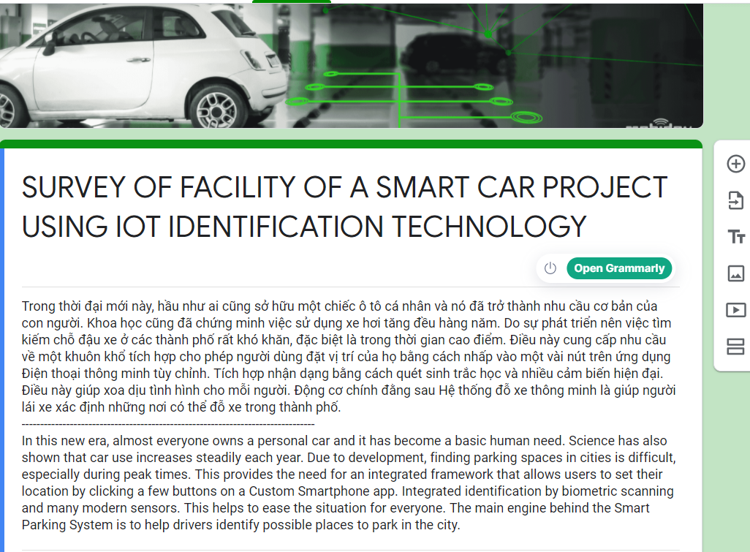

Figure : Survey of customers before project implementation

* **Survey 1**

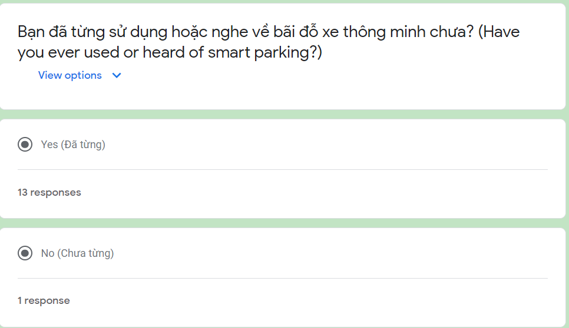

Figure : Survey

Based on the question of whether the customer has been in fact used or has heard about a similar project (figure 2). It can be seen that only 1 person has chosen to never use and know about the project, 13 people have used and known the project, proving that the project has been widely known in the market. If we do, it would be no problem showing the client what this project is all about, just show them the technological and functional benefits that the project has.

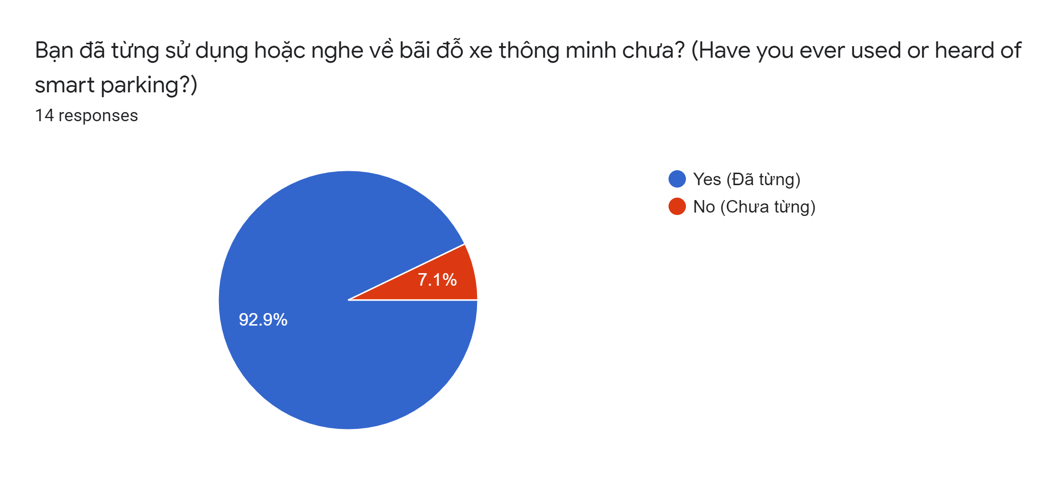

Figure : Summary

* The summary shows that 92.9% (13 people) chose "Yes"
* And 7.1% (1 person) choose "No".
* **Survey 2**

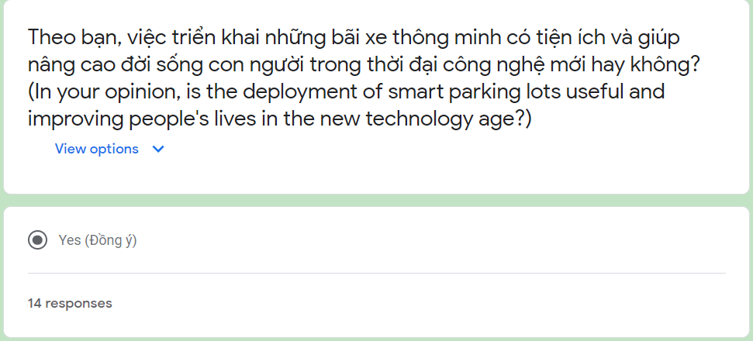

Figure : Survey 2

The question of whether the deployment of smart car parks is useful and helps improve people's lives in the new technology age or not (figure 4). Through the survey, all 14 people chose yes, proving that the project is highly expected by customers for a convenient life, a smart city in the future, especially in the era of technology 4.0.

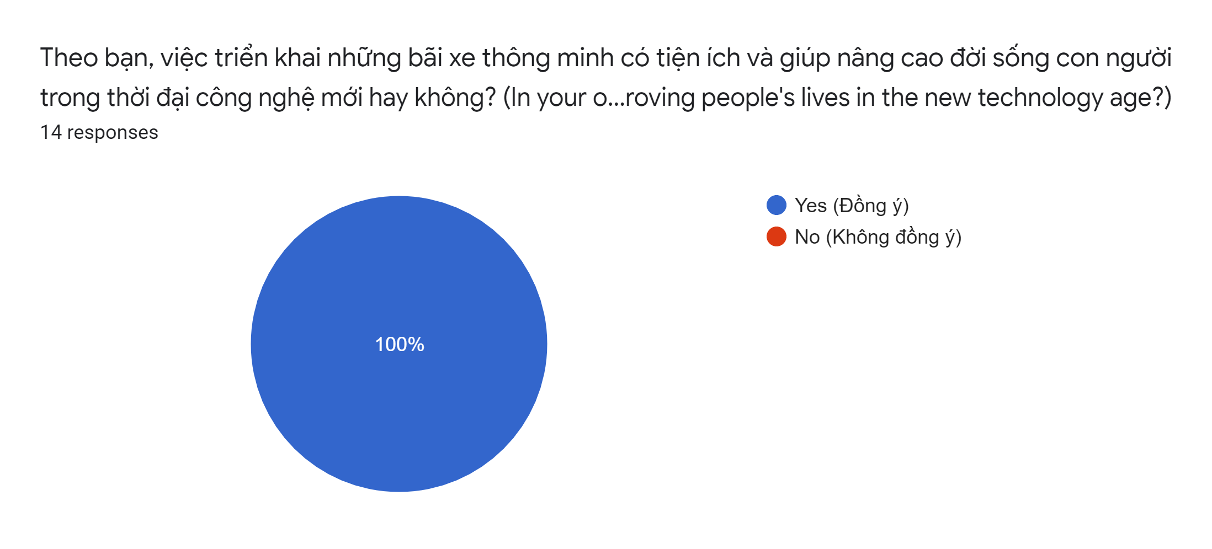

Figure : Summary 2

• The summary shows that 100% (14 people) choose "Yes"

* **Survey 3**

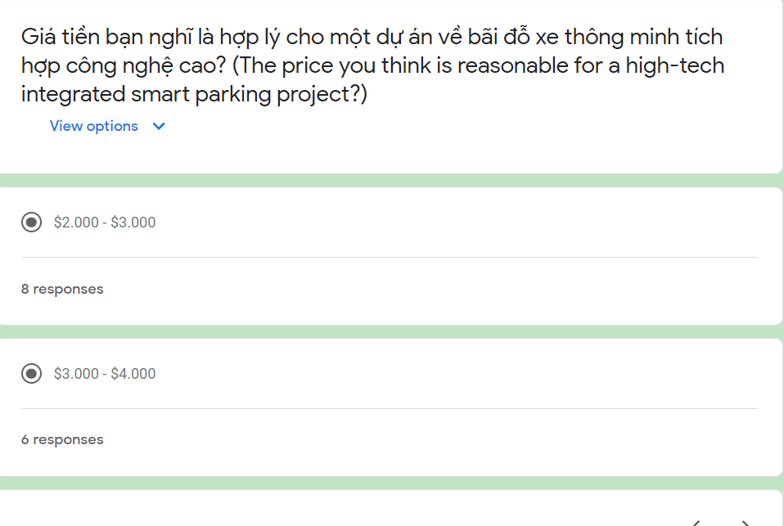

Figure : Survey 3

As for the question "what price do you think is reasonable for a high-tech integrated smart parking project?" (figure 6). The customer choice is relatively different for two prices with eight people choosing between $ 2000 - $ 3000, six people choosing between $ 3000 - $ 4000. Thereby, we can see that the cost when implementing the project actually to the market is very concerned by customers about the price is not too high.

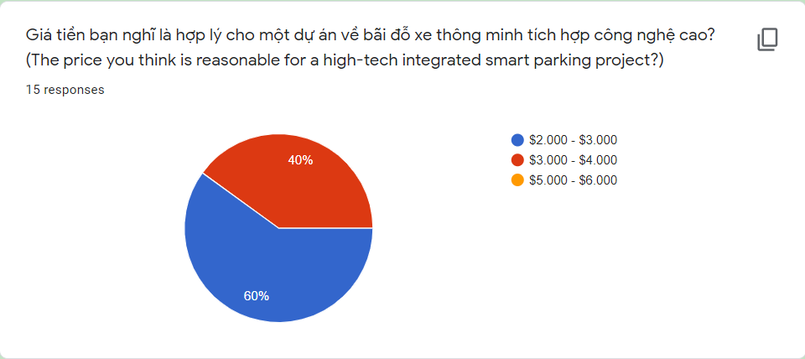

Figure : Summary 3

• The summary shows that 60% (8 people) chose "$2000 - $3000"

• And 40% (6 person) choose "$3000 - $4000".

* **Survey 4**

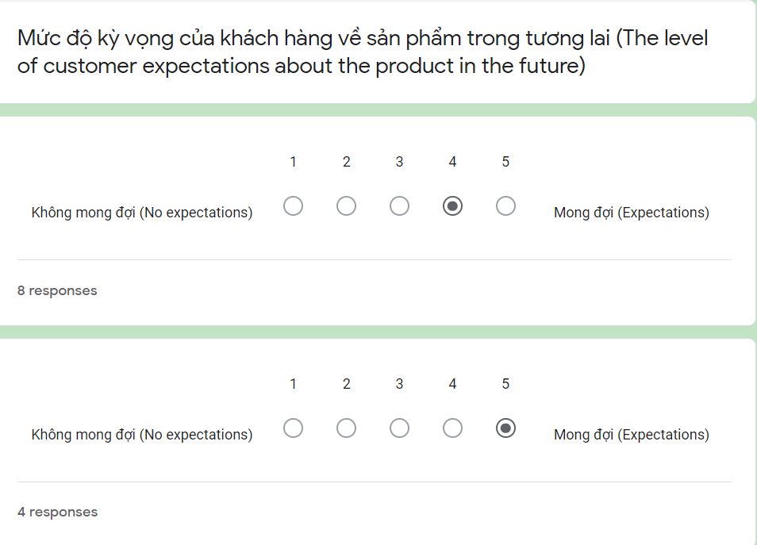

Figure : Survey 4

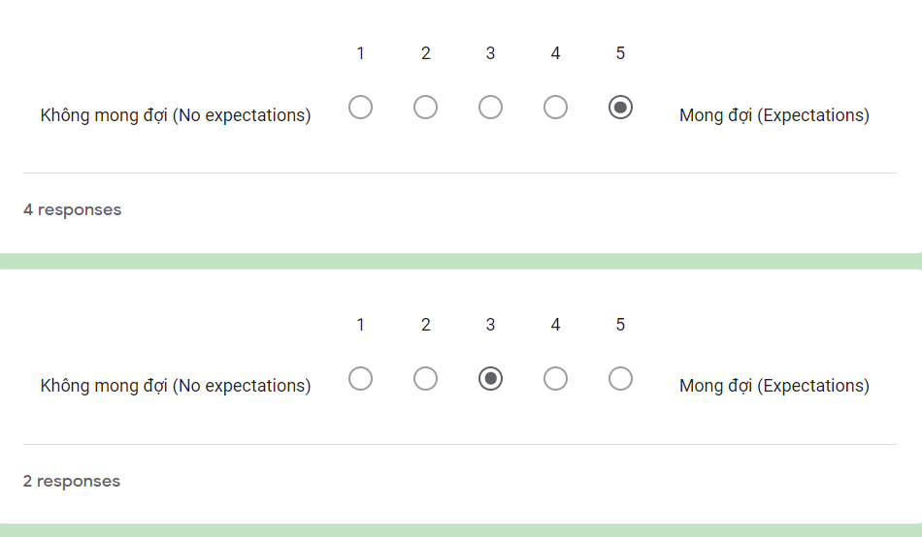

Figure : Survey 4.1

With the question "the level of customer expectations about the product in the future" (figure 9), the customer is evaluated based on a linear scale from 1 to 5, through the results we can see that four people choose level 5 / 5 they look forward to the project. Eight people chose 4/5 and two chose 3/5 (average). Through the collected results, we can comment that although each person's thoughts are different, the way they give their expectations about the project is very high, no one chooses not to expect in the project. Proving that people are also interested in the smart parking project, they want to experience reality in the future.

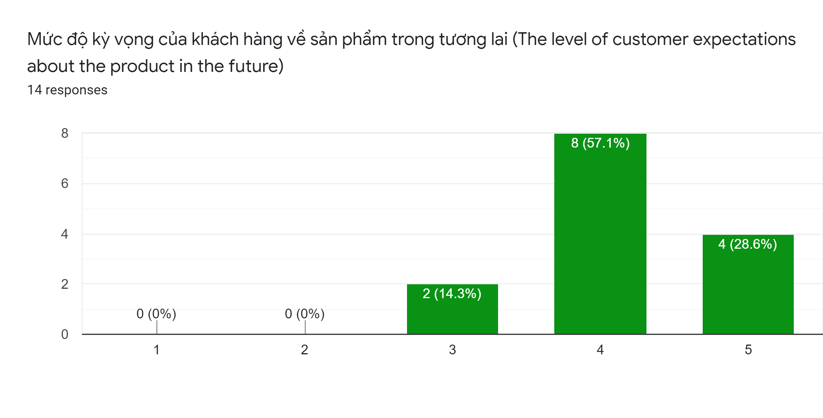

Figure : Summary 4

* Four people choose level 5 / 5.
* Eight people choose 4/5
* Two choose 3/5
* **Survey 5**

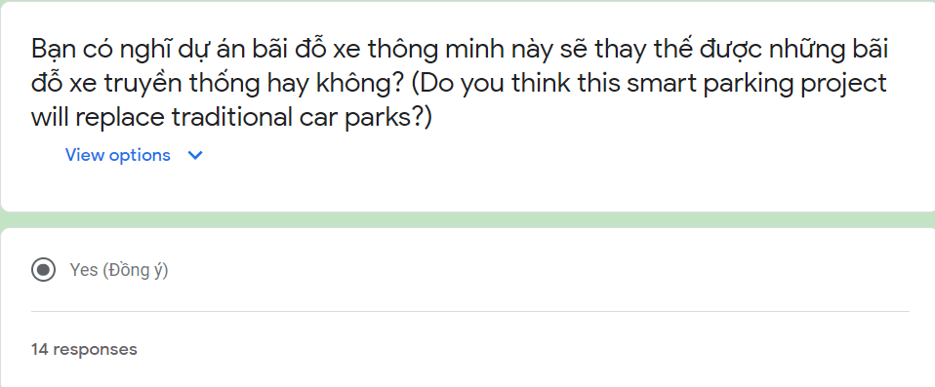

Figure : Survey 5

As for the question "do you think this smart parking project will replace traditional car parks?" (figure 11). Surprisingly, all customers answered "yes". Demonstrate that customers want a breakthrough project, using modern technology to help improve people's lives, replace outdated technologies.

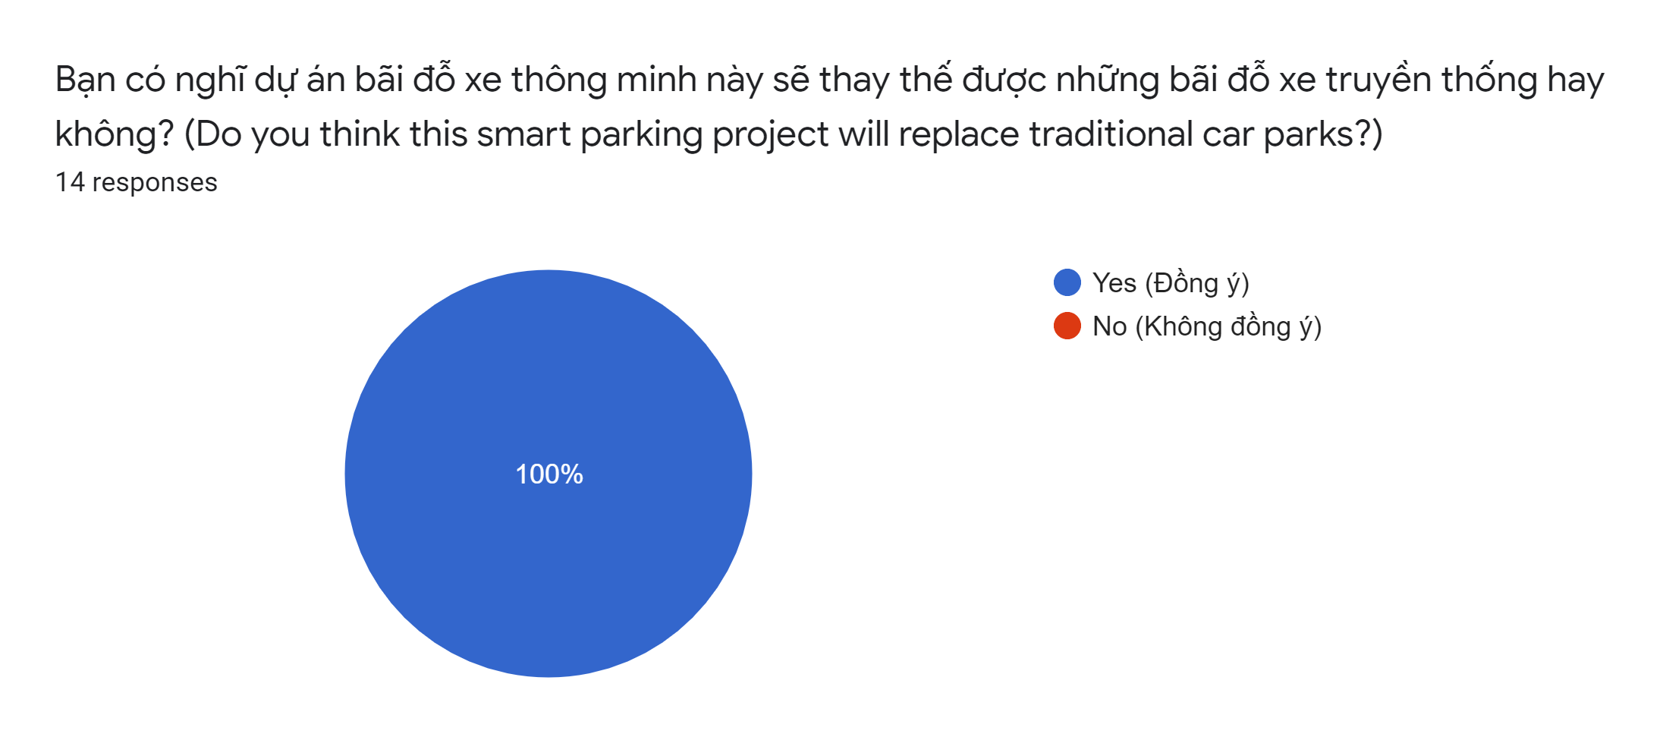

Figure : Summary 5

* The summary shows that 100% (14 people) chose "Yes"
* **Customer comments on the project**

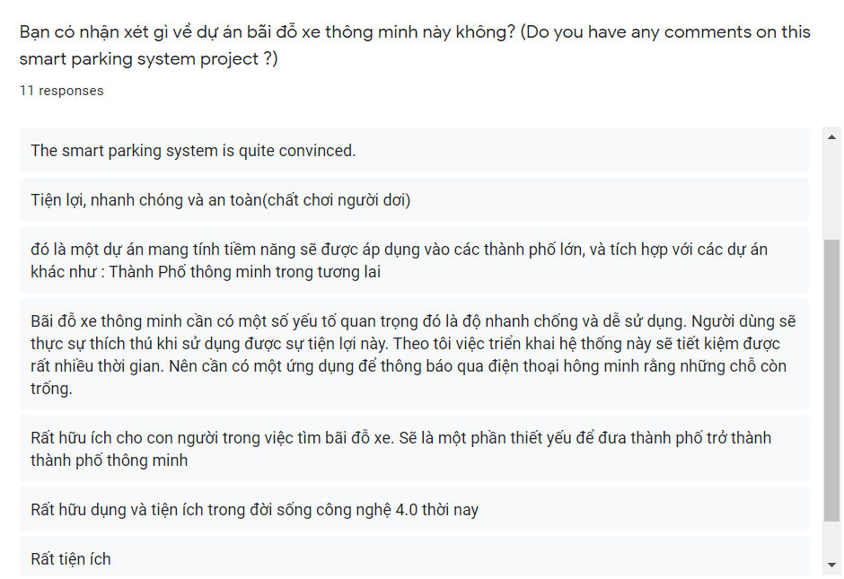

Figure : Customer comments on the project

In general, from the comments and opinions of the customer, we can see that the customer also wants the project to be implemented in the future. They want to experience the benefits that technology brings in the future.

* **The technology used in the survey**

The technology used in the survey is “Google forms”. We use google forms because the interface is easy to use, customers just need a smartphone to do surveys. Technology is easy to use, not too difficult to reach users.

Make it easy for us to create customer survey questions, with google built-in forms like linear scales. We have received customer comments and reviews about their interest in the project. Customers also offer the price they want. And they believe that this smart parking project will replace parking lots with outdated technology, contributing to a smart city in the future.

* **Evaluate the accuracy of the interview**

We conduct the survey in bilinguals because our target market is customers in Vietnam, especially drivers. Because the project will help them solve the problem of finding parking in the city. Questions created for the survey are questions that we need to survey customers' opinions to come up with solutions for the project such as price, ... so that when the project is deployed to the market will easy to reach users.

We found that all customer responses spoke honestly about their opinions, their wishes about the project in the future, about the project's price. Through surveying 14 people, we found that these are practical answers that help a lot in the implementation of the project.

* **Results of the survey**

Overall, all the clients have expressed their opinions and wishes, which is the main purpose of the survey that we desperately need to revise and implement the project. The purpose is to bring the best quality to the user.

P6 Communicate appropriate recommendations as a result of research and data analysis to draw valid and meaningful conclusions.

* **Recommended system summary**

In this new era, almost everyone owns a personal car and it has become a basic human need. It has also been scientifically proven that car use is steadily increasing each year. Due to development, finding parking spaces in cities is difficult, especially during peak times. This provides the need for an integrated framework that allows users to set their location by clicking a few buttons on a Custom Smartphone app. This helps to ease the situation for each person. The key engine behind the Smart Parking System is to help drivers identify possible places to park in the city.

Our project uses cameras to capture number plates of each customer entering and leaving the parking lot and combined biometric scanning to ensure security, then information is stored in the cloud for possible management. easy to access. The project also applies modern sensors and signal lights to warn customers to park at the right place and specially to find vacant positions through applications on smartphones.

* **List of features for the recommended system**

The list of features for the system recommended for that project is

* Arduino programming language
* Native Mobile App to design apps running on mobile platforms for locating users.
* GPS navigation
* Cloud computing and databases to store customer information
* Biometric scanner to ensure security
* Control system: use a long-range FRID card reader dedicated to cars
* Sensor and LED modern warning
* **Advantages of the system**
* Programming language Original mobile application designs mobile apps for users to navigate effectively. Help customers easy to use to find parking in the city and a nice interface for everyone to use.
* The camera works efficiently, captures, and stores customer license plates, and returns results to the system quickly.
* Database and cloud computing to store customer information for easy access by management and highly secure vendor
* **Disadvantage of the project**
* Besides the advantages of making it easy for the customer to use, the project encountered a number of technical problems such as
* The biometric scan system encountered some errors and returned slow results, because of the limited project budget our biometric scanner chosen is not the best on the market, so it will be difficult to high-level security for the car park.
* The sensor system warns when customers park their car in the parking lot with some errors in the code, sometimes warnings do not warn when users put the car into the parking lot.

**P7** Reflect on the value of undertaking the research to meet stated objectives and own learning and performance

* **Logbook**

|  |  |  |  |  |  |
| --- | --- | --- | --- | --- | --- |
| An IoT-Based Smart Parking System | | | | | |
| Begin date: 09/11/2020 | | | | Estimate end date: 10/11/2020 | |
| Schedule | | Actual | | Actions | Problems and chances |
| Begin date | End date | Begin date | End date |
| 11/09/2020 | 15/09/2020 | 11/09/2020 | 15/09/2020 | Project Planning: |  |
| 16/09/2020 | 24/09/2020 | 16/09/2020 | 24/09/2020 | Capital Mobilization |  |
| 25/9/2020 | 28/9/2020 | 25/9/2020 | 28/9/2020 | Project Calculation |  |
| 29/9/2020 | 1/10/2020 | 29/9/2020 | 1/10/2020 | Collect Data About The Project |  |
| 2/10/2020 | 26/10/2020 | 2/10/2020 | 26/10/2020 | Data Selection, Review, Evaluation | While collecting data on the project, we have difficulty in selecting data to suit the project, so that research and implementation can be easily reached by users. |
| 27/10/2020 | 2/11/2020 | 27/10/2020 | 2/11/2020 | Review Of Statistics For Technology Application | It is difficult to choose technologies to use for the project because project costs are limited, so the selection of technologies and equipment must be "affordable". |
| 3/11/2020 | 4/11/2020 | 3/11/2020 | 4/11/2020 | Write a report |  |
| 5/11/2020 | 5/11/2020 | 5/11/2020 | 5/11/2020 | Present |  |
| 6/11/2020 | 10/11/2020 | 6/11/2020 | 10/11/2020 | Project impact analysis |  |

* **Performance review**

During project implementation. The problems that we encountered that directly affected the project were the problem of finding documents related to the project, as there are many car parks projects on the market today. However, their projects use modern equipment and technology for large projects. As for our project, our target is small-scale projects for all customers to easily use. So the selection of data, information, and technology equipment is very difficult, but fortunately, the project has been implemented on schedule.

* **Lessons learned from project implementation**

The lesson we learn from the project process is to select data that must be practical with the goals that the project originally set out. Through the process of doing surveys, we realize that the thinking and desire of current customers are that they want to experience advanced technologies and want those technologies to be applied to our models and project judgment around their life.

# References

Greenwich, 2020. *Session 13 - Research,* s.l.: s.n.

Greenwich, 2020. *Session 14 - Literature search and reviews,* s.l.: s.n.